**XYZ Bank - Documentation**

The XYZ Bank application it's an application created for the usability both of the costumers and the bank manager. With this app the customer should be able to check his bank account and see the transactions he has made over one period, the credit balance and he can deposit or withdrawal money to and from his bank accunt.

* When entering the application it should display a screen with the possibility to select Bank Manager Login or Customer Login.

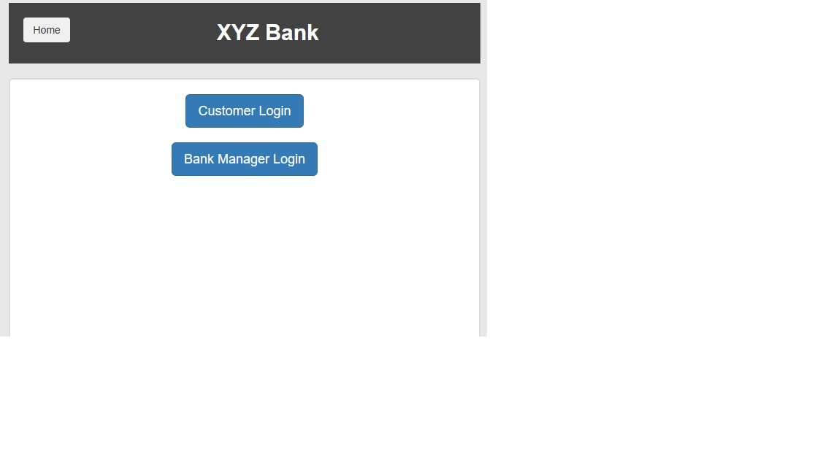As a bank manager user I need to login into my account using the valid credentials for my account.

After checking the Bank Manager Login section, the app will open a modal where I need to introduce my username at the User field and password at the Password field. After the user enters his valid credentials the Login button is pressed and the bank manager section will open and we will have the following subsections.

When the user selects Bank Manager Login the app will open and it can have the following buttons:

1. Add Customer – when pressing the add customer button, the app will open the fields to can create a new customer. The modal will contain:

* First name field: the customer should enter his real first name and it will be a string type. The field it’s a required field, so a new customer can’t be created without complete the field.
* Last name: the customer should enter his real last name and it will be a string type. The field it’s a required field, so a new customer can’t be created without complete the field.
* Post code: the customer should enter his post code, that will be formed only by numeric characters. The field it’s a required field, so a new customer can’t be created without complete the field.
* SSN (Social Security Number) - the customer should enter his real SSN, that will be formed by numeric characters. The field it’s a required field, so a new customer can’t be created without complete the field.
* Email address: the customer should enter his valid email address. When the add customer button it’s pressed, an automatically email will be send to the new customer, that will be needed when he will open a new account.
* Add Customer button – should be white and when hover should be grey. After all the fields valid and completed and the user press add customer button, the message will be displayed: Customer added successfully with customer id:(the customer ‘s number).
* If you try to create a new customer without complete all the fields, then a message will be displayed: “Please fill out this field”.
* You cannot enter the same customer twice.

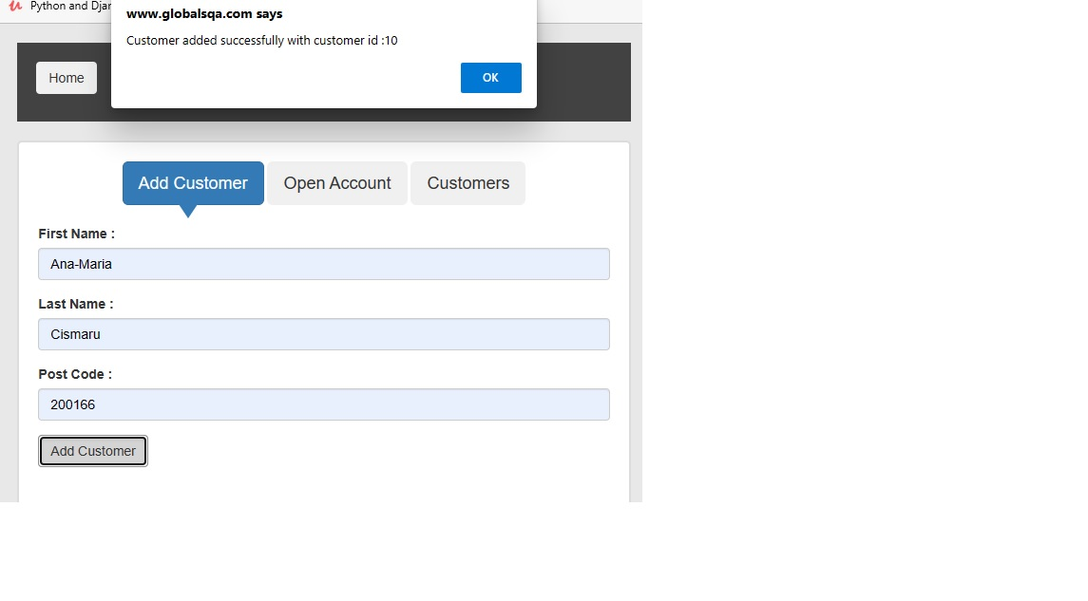2. Open Account section:

When pressing the open account section, the following fields will appear into the modal:

* Customer – you should choose the new customer’s name that you have created previously. You can either type or select it from the drop down. This field is a required field.
* Currency: - you should be able to choose from the drop down the actual currency that you want your account to have. You can choose it from the drop down list with all the currency existing at this time. This field is a required field.
* Personal Numeric Code – enter the personal numeric code that was automatically sent to your email address when you have created a new customer. It is a numeric code formed by 7 numbers. This field is a required field.
* Process button – press the process button to can successfully open an account. The message should be desplay: “Account created successfully with account Number: “

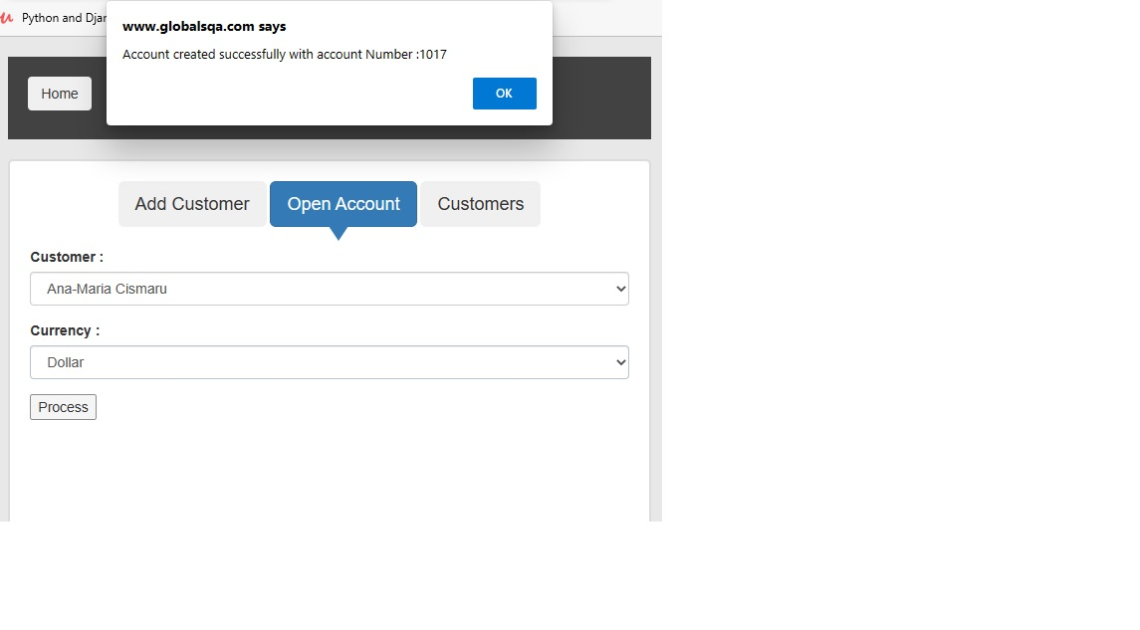3. Customers section

When pressing the customer section it should be a list with all the customers that have been created and the list should contain the details of the customer and the possibility to delete the customer from the bank fields.

* Customer ID – it should be the id that was generated when the customer was created. It is a numeric code and the bank manager should not have the possibility to change or modify it.
* First Name – it should be the first name that was completed when created the customer. The manager should be able to organized the section by alphabet, from A to Z.
* Last Name – it should be the last name that was completed when created the customer. The manager should be able to organized the section by alphabet, from A to Z.
* SSN – It should be the social security number entered when a new customer was created.
* Account number – it should be the account number that was created when the customer opens an account.
* Currency – it should be displayed the currency selected when a new account was opened.
* Delete customer – when the bank manager want s to delete a customer, he can be able to do that only by pressing the delete button. The delete button will be used only by the authorized personal, in the limit of the low, based on the bank protocol that exists.

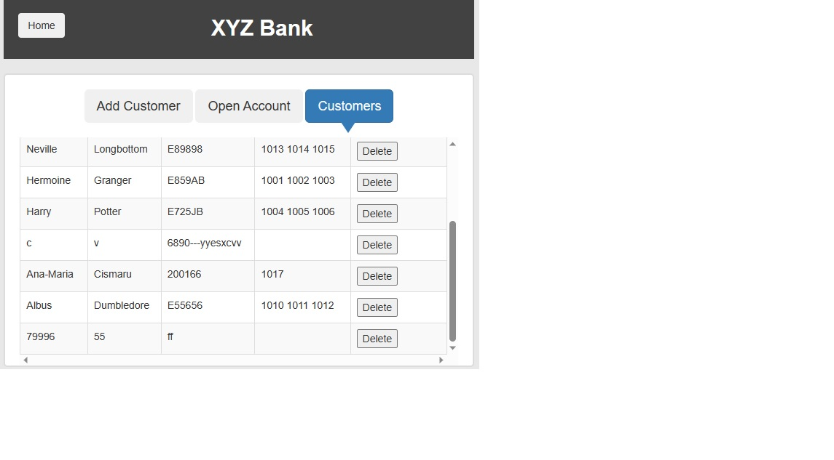 The **XYZ Bank** app should be both used by the bank’s authorized personal, like the manager and by the customer directly.

The customer can login and use the app only after the bank manager will create an customer account for him. After the customer is created into the system, the customer, client, can login by himself into the application by follow the next steps:

Go to the app: [XYZ Bank (globalsqa.com)](https://www.globalsqa.com/angularJs-protractor/BankingProject/" \l "/account) select the customer login field, after that, select his own name in the field your name and press the Login button.

The customer section will then show the following fields: Transactions, Deposit, Withdrawal - section that the customer can check, the Logout and Home button.

The account number, balance and currency will be also shown with the details of the moment shown.

* Transactions – this section will show all the transaction that the customer has made by deposit or by withdrawal money. The transaction section will shown the following fields: Date-Time – that will show when the transaction was made by date and hour, the amount – will display the amount of money that were in the transaction and the Transaction type that will be either credit or debit type.
* The customer will have two fields where he can choose the time x to time y that will shown the transactions that were made between that period.
* He can also have the possibility to reset all those transactions, by pressing the Reset button, or to go back to the main screen by pressing the Back button.
* The customer can make a deposit by selecting the Deposit section. A filed will open with the Amount to be deposited name and he can enter there the amount he want to deposit into his own bank account. The amount will be numeric type can be only more then 1 Euro or the equivalent once. After the customer enters the amount he needs to press the Deposit button and a message will be seen : “Deposit Successful”.
* The Withdrawal section will display the amount to be Withdrawn message after pressing on the Withdrawal section. The customer should enter the amount he wants to withdrawn and if he has the amount into the bank account, the operantion will succede and the message “Transaction successful” will be shown, if not, then the message will be displayed: Transaction Fieled. You can not withdraw amount more then your current balance.
* You can only make 2 withdrawals in 24 h.